MAT 303 Project Two Summary Report

Kyle Payne
kyle.payne2@snhu.edu
Southern New Hampshire University

1. Introduction

For this project I am using the cleaned Heard Disease data set (heart_disease.csv). The file contains patient-level measures such as age, resting blood pressure, chest pain type, and maximum heart rate, along with a binary outcome that indicates whether heart disease is present. The goal is to build models that estimate the probability of heart disease from routine clinical measurements and to evaluate how well those models classify patients. These results can help an interdepartmental research teams understand which indicators are more associated with risk and decide whether a model is accurate enough to assist with screening and decision support.

I will run two kinds of analyses. First, I will fit two logistic regression models for the binary outcome target (0 = no heart disease, 1 = heart disease). Model 1 uses age, resting blood pressure, exercise-induced angina, and maximum heart rate achieved. Model 2 uses age, a quadratic term for age, chest pain type, resting blood pressure, maximum heart rate, and an interaction between age and maximum heart rate. I will assess each logistic model with the Hosmer-Lemeshow goodness-of-fit test, Wald tests, and a confusion matrix with accuracy, precision, and recall, and an ROC curve with AUC. Second, I will build tree-based models: a random forest classifier to predict the presence of heart disease and a random forest regressor to predict maximum heart rate. I will use training and testing splits to report performance, including RMSE for the regression model.

2. Data Preparation

The data file contains common clinical predictors and a binary outcome. The important variables are:

- target: heart disease indicator, 0 = no, 1 = yes
- age: age in years
- sex: 1 = male, 0 = female
- cp: chest pain type, 0 = no pain, 1 = typical angina, 2 = atypical angina, 3 = non-anginal pain
- trestbps: resting blood pressure in mm Hg
- chol: serum cholesterol in mg/dl
- fbs: fasting blood sugar greater than 120 mg/dl, 1 = true, 0 = false
- restecg: resting electrocardiographic result
- thalach: maximum heart rate achieved
- exang: exercise-induced angina, 1 = yes, 0 = no
- oldpeak: ST depression induced by exercise relative to rest
- slope: slope of the peak exercise ST segment
- ca: number of major vessels colored by fluoroscopy
- thal: thalassemia category

In the notebook setup, categorical fields are converted to factors to fil logistic and tree models correctly. These include target, sex, cp, fbs, restecg, exang, slope, ca, and thal.

The dataset has 303 rows and 14 columns.

3. Model #1 - First Logistic Regression Model

Reporting Results
Let π be the probability that an individual has heart disease (target = 1). With predictors age (age), resting blood pressure (trestbps), exercise-induced angina (exang; coded 1 = yes, 0 = no), and maximum heart rate achieved (thalach), the logistic regression model is:

$$E\left(Y\right)=π=\frac{e^{β_{0}+β_{1}age+β_{2}trestbps+β_{3}exang{+β}_{4}thalach}}{1+e^{β_{0}+β_{1}age+β_{2}trestbps+β_{3}exang{+β}_{4}thalach}}$$

Linear (log-odds) form
Taking the natural log of the odds transforms the model into a linear relationship in the betas:

$$\ln\left(\frac{π}{1-π}\right)=β_{0}+β_{1}age+β_{2}trestbps+β_{3}exang{+β}_{4}thalach$$

- π is the predicted probability that a person will have heart disease.
- $\left(\frac{π}{1-π}\right)$ is the odds of having heart disease. Odds compare the chance of having heard disease to the chance of not having heart disease. The odds value of two means heart disease is twice as likely as not having heart disease.

Prediction Model Using the Fitted Coefficients

$$\ln\left(odds\right)=-1.0211-0.0175\left(age\right)-0.0149\left(trestbps\right)-1.6249\left(exang\right)+0.0311(thalach)$$

Equivalently, the predicted probability of heart disease is:

$$\hat{π}=\frac{e^{-1.0211-0.0175\left(age\right)-0.0149\left(trestbps\right)-1.6249\left(exang\right)+0.0311(thalach)}}{1+e^{-1.0211-0.0175\left(age\right)-0.0149\left(trestbps\right)-1.6249\left(exang\right)+0.0311(thalach)}}$$

Interpretation of the Maximum Heart Rate Coefficient
The estimated coefficient for maximum heart rate (thalach) is 0.0311. Holding the other variables constant, a 1 bpm increase in maximum heart rate increases the log-odds of heart disease by 0.0311. The odds ratio is $e^{0.0311}=1.0316.$ That is about 3.16% increase in the odds of heart disease for each additional bpm of maximum heart rate in this model.

Evaluating Model Significance

Hosmer-Lemeshow Goodness-Of-Fit
- H₀: The model fits the data adequately.
- H_{a}: The model does not fit the data adequately.
- Test statistic: X² = 303.0000, df = 8.
- p-value < 2.2 X 10-¹⁶.

At α (alpha) = 0.05, we reject H₀. This indicates a lack of fit, so this simple specification may not capture the structure in the data well.

Wald Test (Significance of Individual Terms, α = 0.05)
- age: p-value = 0.3060 (not significant)
- trestbps: p-value = 0.0741 (not significant)
- exang: p-value = 1.07 X 10⁻⁷ (significant)
- thalach: p-value = 1.92 X 10⁻⁵ (significant)

Confusion Matrix Counts
 | Actual = 0 | Actual = 1
Predicted = 0 | 89 True Negatives | 31 False Negatives
Predicted = 1 | 49 False Positives | 134 True Positives

Model Performance

- Accuracy = (TP + TN)/TOTAL: 0.736 The model gives the correct heart disease status for about 73.6% of individuals.
- Precision = TP/(TP+FP): 0.7322 When the model predicts heart disease, it is correct roughly 73.2% of the time.
- Recall = TP/(TP+FN): 0.8121 The model successfully identifies about 81.2% of all actual heart disease.

ROC Curve and AUC
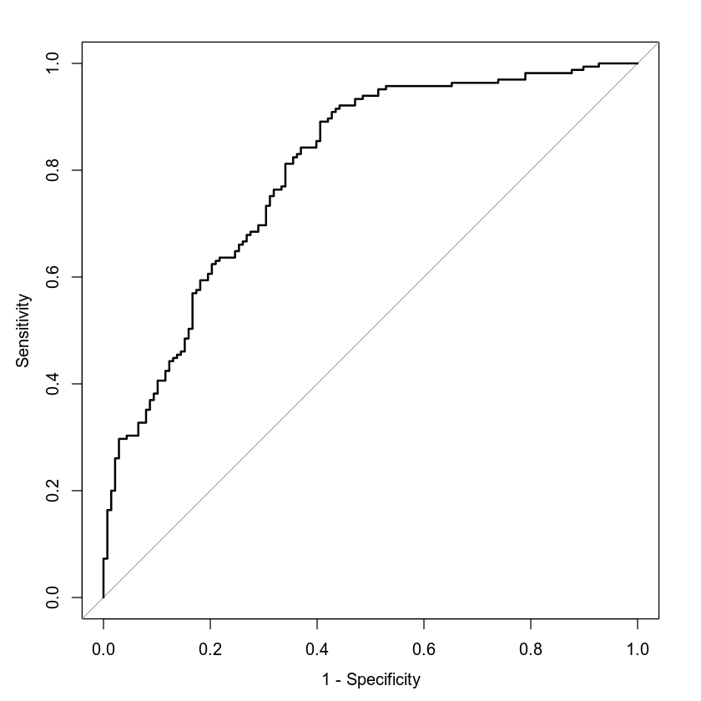
The ROC curve lies well above the diagonal, which shoes the model discriminates better than random guessing across thresholds. The area under the curve is AUC = 0.8007. An AUC around 0.80 means that if we pick one person with heart disease and one without at random, the model assigns a higher predicted risk to the diseased person roughly 80% of the time.

Making Predictions Using Model

Scenario A Prediction
For a 50-year-old with resting blood pressure of 122, exercise-induced angina = 1, and maximum heart rate of 140, the fitted model gives a probability of heart disease = 0.2716 and odds = 0.3728. The odds value means that for every one expected case without heart disease, there are about 0.37 expected cases with heart disease in patients like this.

Scenario B Prediction
For a 50-year-old with resting blood pressure of 130, exercise-induced angina = 0, and maximum heart rate of 165, the fitted model gives a probability of heart disease = 0.7853 and odds = 3.6571. This means there are about 3.66 expected cases with heart disease for every one expected case without heart disease in patients like this.

Comparison of the Two Predictions
The model assigns a much higher risk to scenario B than to scenario A. The odds in scenario B are about 9.8 times the odds in scenario A (3.6571/0.3728 = 9.8). This difference is consistent with the fitted coefficients: the model estimates a positive effect for maximum heart rate, so the higher thalach of 165 in scenario B increases risk compared with 140 in scenario A, and the negative coefficient on the exang means having exercise-induced angina (scenario A) is associated with lower risk than not having it (scenario B) in this specification. The change in resting blood pressure is a smaller impact according to the model and does not outweigh the combine effects of thalach and exang.

4. Model #2 - Second Logistic Regression Model

Reporting Results
Let π be the probability that an individual has heart disease (target = 1). With predictors age (age), resting blood pressure (trestbps), chest pain type (cp coded; 0 = no pain, 1 = typical angina, 2 = atypical angina, 3 = non-anginal pain), maximum heart rate achieved (thalach), a quadratic term in age, and the interaction between age and maximum heart rate, the logistic regression model is:

$$E\left(y\right)=π=\frac{e^{β_{0}+β_{1}age+β_{2}trestbps+β_{3}cp1{+β_{4}cp2+β_{5}cp3+β}_{6}thalach+β_{7}{age}^{2}+β_{8}age*thalach}}{1+e^{β_{0}+β_{1}age+β_{2}trestbps+β_{3}cp1{+β_{4}cp2+β_{5}cp3+β}_{6}thalach+β_{7}{age}^{2}+β_{8}age*thalach}}$$

Linear (log-odds) form
Taking the natural log of the odds transforms the model into a linear relationship in the betas:

$$\ln\left(\frac{π}{1-π}\right)=β_{0}+β_{1}age+β_{2}trestbps+β_{3}cp1{+β_{4}cp2+β_{5}cp3+β}_{6}thalach+β_{7}{age}^{2}+β_{8}age*thalach$$

- π is the predicted probability that a person will have heart disease.
- $\left(\frac{π}{1-π}\right)$ is the odds of having heart disease. Odds compare the chance of having heard disease to the chance of not having heart disease. An odds value of two means heart disease is twice as likely as not having heart disease.

Prediction Model Using the Fitted Coefficients

$$\ln\left(odds\right)=-15.5637+0.1744\left(age\right)-0.0196\left(trestbps\right)+1.9135\left(cp1\right)+2.0373\left(cp2\right)+1.7773\left(cp3\right)+0.1363\left(thalach\right)+0.0008{\left(age\right)}^{2}-0.0019(age*thalach)$$

Equivalently, the predicted probability of heart disease is:

$$\hat{π}=\frac{e^{-15.5637+0.1744\left(age\right)-0.0196\left(trestbps\right)+1.9135\left(cp1\right)+2.0373\left(cp2\right)+1.7773\left(cp3\right)+0.1363\left(thalach\right)+0.0008{\left(age\right)}^{2}-0.0019(age*thalach)}}{1+e^{-15.5637+0.1744\left(age\right)-0.0196\left(trestbps\right)+1.9135\left(cp1\right)+2.0373\left(cp2\right)+1.7773\left(cp3\right)+0.1363\left(thalach\right)+0.0008{\left(age\right)}^{2}-0.0019(age*thalach))}}$$

Evaluating Model Significance

Hosmer-Lemeshow Goodness-Of-Fit
- H₀: The model fits the data adequately.
- H_{a}: The model does not fit the data adequately.
- Test statistic: X² = 303.0000, df = 8.
- p-value < 2.2 X 10-¹⁶.

At α (alpha) = 0.05, we reject H₀. This indicates a lack of fit, so this simple specification may not capture the structure in the data well.

Wald Test (Significance of Individual Terms, α = 0.05)
- age: p-value = 0.5136 (not significant)
- age²: p-value = 0.6303 (not significant)
- trestbps: p-value = 0.0292 (significant)
- cp1: p-value = 1.61 X 10⁻⁵ (significant)
- cp2: p-value = 4.45 X 10⁻⁹ (significant)
- cp3: p-value = 0.0012 (significant)
- thalach: p-value = 0.0078 (significant)
- age:thalach: p-value = 0.0362 (significant)

Confusion Matrix Counts
 | Actual = 0 | Actual = 1
Predicted = 0 | 102 True Negatives | 36 False Negatives
Predicted = 1 | 36 False Positives | 129 True Positives

Model Performance
- Accuracy = (TP + TN)/TOTAL: 0.7624 The model gives the correct heart disease status for about 76.2% of individuals.
- Precision = TP/(TP+FP): 0.7818 When the model predicts heart disease, it is correct roughly 78.2% of the time.
- Recall = TP/(TP+FN): 0.7818 The model successfully identifies about 78.2% of all actual heart disease.

ROC Curve and AUC
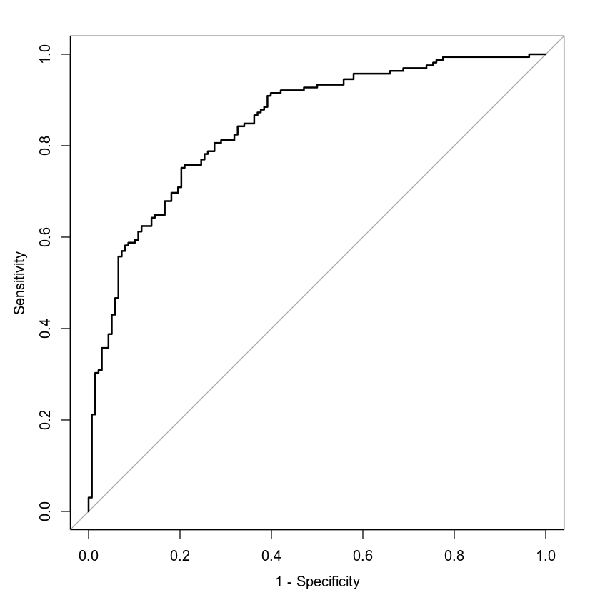

The ROC curve rises well above the diagonal reference line, showing good discrimination across thresholds, and the area under the curve is AUC = 0.8478. An AUC near 0.85 indicates that, for a randomly chosen pair of patients where one has heart disease and the other does not, this model assigns a higher predicted risk to the diseased patient about 85% of the time.

Making Predictions Using Model

Scenario A Prediction
For a 50-year-old with resting blood pressure of 115, no chest pain reported, and maximum heart rate of 133, the model estimates a probability of heart disease = 0.6235 and odds = 1.6561. Odds above one mean that the event is more likely than not for someone with this profile.

Scenario B Prediction
For a 50-year-old with resting blood pressure of 125, typical angina, and maximum heart rate of 155, the model estimates a probability of heart disease = 0.3722 and odds = 0.5929. Odds below one means the event is less likely than not for this profile.

Comparison of the Two Predictions
The model assigns a higher risk to scenario A than to scenario B. The odds in scenario A are about 2.8 times the odds in scenario B (1.6561/0.5929 = 2.8). The difference is consistent with the fitted coefficients: compared with typical angina, the indicator for asymptomatic chest pain is associated with higher risk in this model, and the negative coefficient on resting blood pressure means the lower value in scenario A raises risk relative to scenario B. The higher maximum heart rate in scenario B increases risk only slightly for a 50-year-old because the interaction between age and maximum heart rate reduces that effect. Overall, the combination of asymptomatic chest pain and lower testing blood pressure drives the higher predicted probability in scenario A.

5. Random Forest Classification Model

Reporting Results
- Data split: original rows = 303: training set = 257; testing set = 46
- Error curves: the training error dropped quickly and stayed near zero. The testing error decreased and then leveled off.
- Optimal trees: the lowest testing error occurred at 49 trees with min test error = 0.2174. I used 49 trees for the final model.

Evaluating the Utility of the model

Training Confusion Matrix Counts (49 Trees)
 | Actual = 0 | Actual = 1
Predicted = 0 | 117 True Negatives | 0 False Negatives
Predicted = 1 | 3 False Positives | 137 True Positives

Model Performance
- Accuracy = (TP + TN)/TOTAL: 0.9883 The model gives the correct heart disease status for about 98.8% of individuals.
- Precision = TP/(TP+FP): 0.9786 When the model predicts heart disease, it is correct roughly 97.9% of the time.
- Recall = TP/(TP+FN): 1.00 The model successfully identifies about 100% of all actual heart disease.

Testing Confusion Matrix Counts (49 Trees)
 | Actual = 0 | Actual = 1
Predicted = 0 | 11 True Negatives | 9 False Negatives
Predicted = 1 | 7 False Positives | 19 True Positives

Model Performance
- Accuracy = (TP + TN)/TOTAL: 0.6522 The model gives the correct heart disease status for about 65.2% of individuals.
- Precision = TP/(TP+FP): 0.7308 When the model predicts heart disease, it is correct roughly 73.1% of the time.
- Recall = TP/(TP+FN): .6786 The model successfully identifies about 67.9% of all actual heart disease.

Interpretation

The model fits the training data very well but performs more modestly on new data. This gap between training and testing results suggests some overfitting and that additional tuning or features could help.

6. Random Forest Regression Model

Reporting Results
- Data split: original rows = 303: training set = 242; testing set = 61
- Error curves: the testing MSE drops sharply in the first few trees and then levels off.
- Optimal trees: 29 trees with min test MSE = 382.4422.

Evaluating the Utility of the Random Forest Regression Model

Using 29 trees to predict maximum heart rate achieved:
- Training RMSE: 11.5479
- Testing RMSE: 20.8523

Interpretation
On the new data, the model’s typical prediction error is about 20.85 bpm. The training error is lower than the testing error, which is expected and suggests some overfitting but within a reasonable range for this simple feature set.

7. Conclusion

This project built and evaluated models to predict heart disease and to predict maximum heart rate achieved from routine clinical measures. I fit two logistic regression models for the binary outcome and two random forest models, one for classification and one for regression. I reported estimates, checked model significance, graphed ROC curves, and measured accuracy, precision, recall, AUC, and RMSE.

Which logistic model would I choose?
I would choose Model 2. It adds chest pain type, a quadratic term for age, and an age by maximum heart rate interaction. Model 2 reached accuracy = 0.7624, precision = 0.7818, recall = 0.7818, and AUC = 0.8478. Model 1 reached accuracy = 0.7360, precision = 0.7322, recall = 0.8121, and AUC = 0.8007. Model 2 improved discrimination and overall accuracy with only a small drop in recall. Its key terms were significant, including chest pain indicators, resting blood pressure, maximum heart rate, and the age by maximum heart rate interaction. Both models failed the Hosmer-Lemeshow test, which means the simple specifications do not capture all of the structure in the data, but Model 2 still provided stronger predictive performance and clearer clinical signals. In plain language, risk was higher for patients reporting chest pain types other than typical angina, the risk increased with maximum heart rate for middle ages in this model, with the interaction indicating that the effect changes with age.

Should we use the random forest classifier instead of logistic regression?
I would not replace the logistic model with the random forest classifier based on these results. The random forest with 49 trees fit the training data extremely well (accuracy = 0.9883), but the performance dropped on the test set (accuracy = 0.6522, precision = 0.7308, recall = 0.6786). This gap suggests overfitting. In contrast, logistic Model 2 kept a stronger balance on unseen data and reached a higher AUC (0.8478). Logistic regression is also easier to interpret and to explain to clinicians because coefficients link each predictor to the odds of heart disease. The random forest could be useful after further tuning or with additional features, but with the current setup the logistic model is the better choice.

How useful is the random forest regression for maximum heart rate?
The regression forest using 29 trees produced RMSE = 11.5479 on training and RMSE = 20.8523 on testing. This means the typical prediction error on new patients is about 21 bpm. That size of error is acceptable for rough estimation or imputation when a maximum heart rate is missing, but it’s not precise enough to replace actual measurement.

Practical importance
These analyses show how routinely collected measures can support screening and decision support. The logistic model converts patient profiles into predicted probabilities and odds, which can help triage patients, prioritize follow up, and guide conversations about risk. Because the ROC curve is strong, the hospital could choose a probability threshold that matches its goals. For example, if the goal is to catch more true cases, the threshold can be lowered to increase recall at the cost of more false positives. The models also highlight which variables carry information about risk in this data set, such as chest pain type, resting blood pressure, and maximum heart rate. Together, these results provide a workable risk tool, show where the current models fall short, and point to next steps such as adding more predictors, considering additional interactions, and using cross-validation to refine model tuning.

